

**E X A M I N O**

Self-Assessment App (Beta)

**COMSATS University Islamabad**

Sahiwal Campus



**Usama Sarwar**

FA17-BS(CS)-090-B

**Waheed Ramay**

Web Development

June 04, 2020

Table of Contents

1. Introduction 3

2. Executive Summary 3

3. Solution Outline 3

4. Modules 4

4.1 Home Screen containing subjects 4

4.2 Assessment Customization 4

4.3 Exam Screen 5

4.4 Result Screen 5

4.5 Answers Screen 6

5. Site Integrations 6

6. Additional Features 6

6.1 Android App (Flutter App) 7

6.2 iOS App (Flutter App) 8

7. Tools and Technology 9

8. Execution Timeline 9

9. Conclusion 9

List of Figures

Figure 1. EXAMINO Home Screen 4

Figure 2. Assessment Customization 4

Figure 3. Assessment Play Screen 5

Figure 4. Instant Result Screen 5

Figure 5. Solution Screen 6

Figure 6. Pixel 2 (Preview) 7

Figure 7. iPhone X (Preview) 8

# Introduction

COMSATS University Islamabad is the top ranked university in Computer Science Department around the country. It has its own content management system named as CU-Online. I’m a student of Computer Science Department at COMSATS University Islamabad contributing in the development of CU-Online system by developing a Self-Assessment Application. The teachers/students create questions of quiz/exam. In such an exam system instructor can create questions and add them to the exam. Teacher can choose between multiple choice questions or True/False Questions. They see the results immediately afterwards. The big benefit of Self-Assessment Application is the cost and time saving, both for students and teachers. The biggest limitation is that you have to be online to use an online examination system. Hence the name "online". Everybody who needs an exam to be taken by a group of students. Users for this project may range from schools and teachers to companies. Obviously, it must be possible to create an exam, and add questions. Preferably the exam provides for the option to create a question bank and you have to be able to set the rules for when a student passes or fails the exam.

# Executive Summary

Self-Assessment means to conduct a test online to measure the knowledge on a given topic. The big benefit of online examination is the cost and time saving, both for students and teachers. The biggest limitation is that you have to be online to use an online examination system. This system can be used by schools, teachers and companies.

# Solution Outline

Many universities are switching to online exams during COVID-19. For one, Oxbridge’s summer assessments are moving online. Over at Imperial College London, 280 medical students successfully completed final-year exams last week. The university says this a historic first for medical studies. Online exams during COVID-19 shows benefits of digital assessment. Online or digital exams can save lecturers ample marking time. It also saves students the hassle of putting pen to paper to demonstrate their knowledge in an area of study. According to the University of Technology Sydney, students are also less anxious about online exams as they can first do practice tests online. This assessment model also explores the possibility of automated marking for standardized tests.

# Modules

The website will have the following modules:

## Home Screen containing subjects

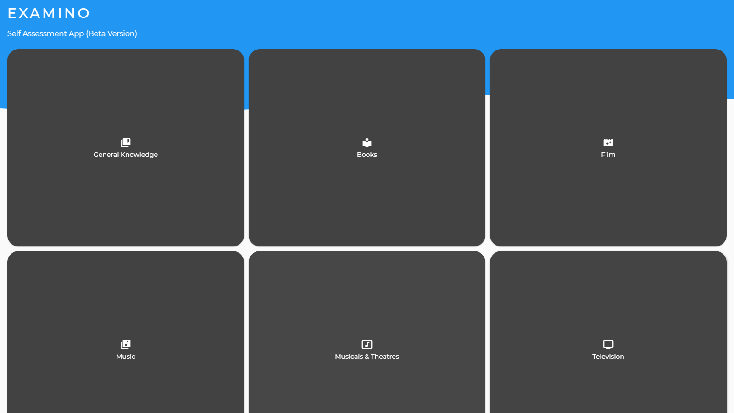

Figure 1. EXAMINO Home Screen

## Assessment Customization

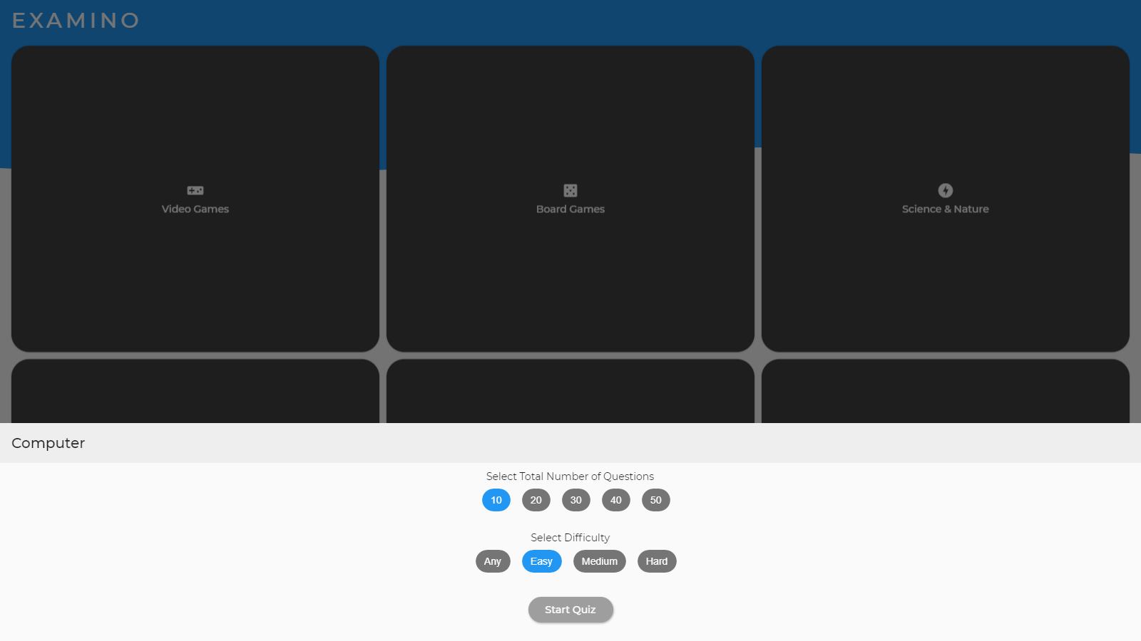

Figure 2. Assessment Customization

## Exam Screen

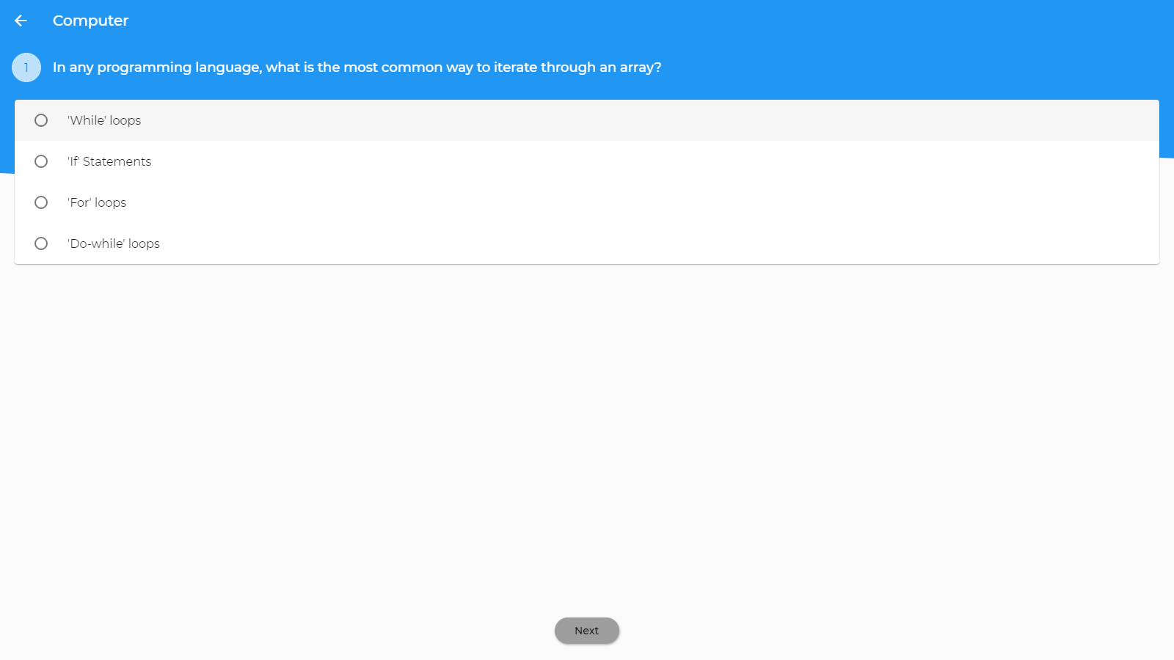

Figure 3. Assessment Play Screen

## Result Screen

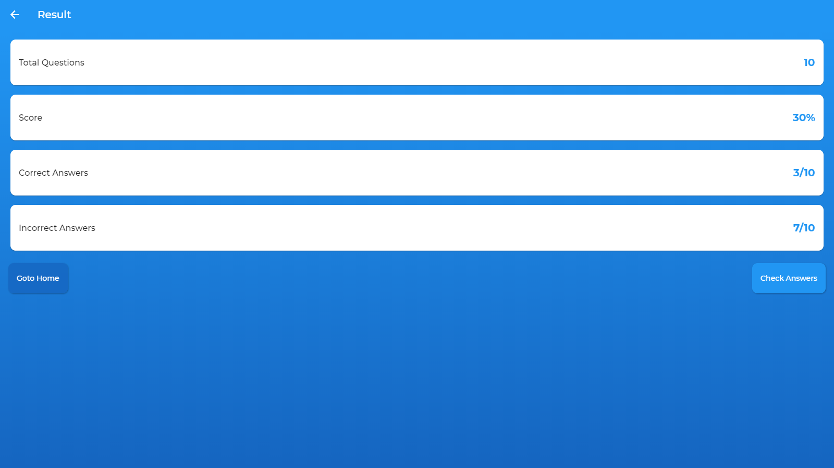

Figure 4. Instant Result Screen

## Answers Screen

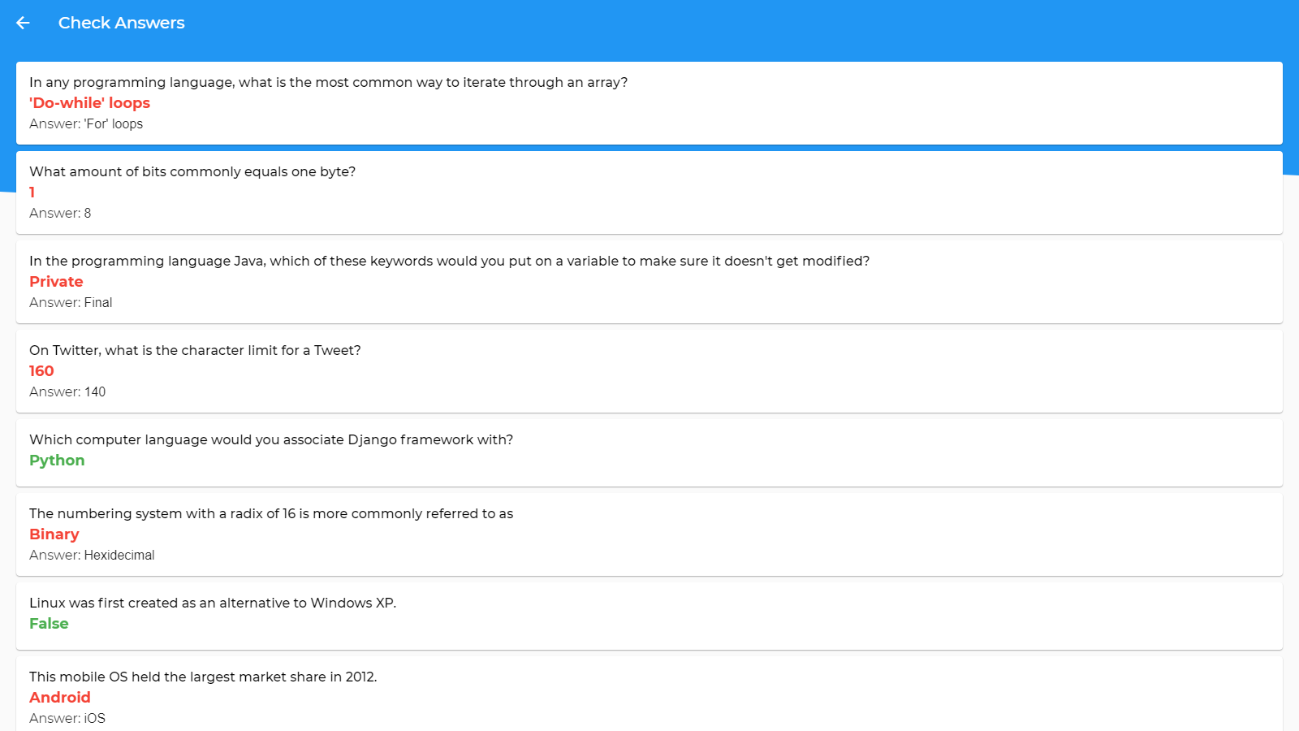

Figure 5. Solution Screen

# Site Integrations

This website is integrated with the following tools:

* [Open Triva Database](https://opentdb.com/) | www.opentdb.com

These integrations will allow you to use your website as a useful exam conducting tool which helps you to check and pass the students.

# Additional Features

Based on previous discussions regarding the goals and expectations, this website will have the following additional features:

* Instant Result
* Instant Answers of the Exam after the exam is completed

## Android App (Flutter App)

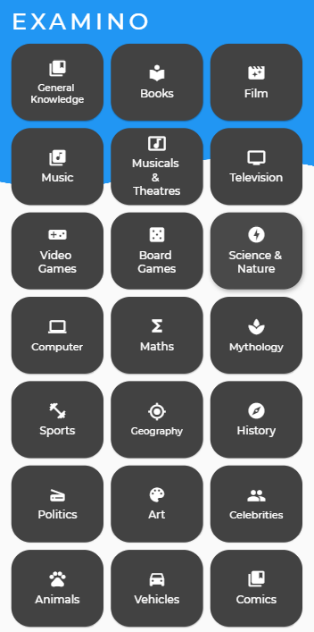

Figure 6. Pixel 2 (Preview)

## iOS App (Flutter App)

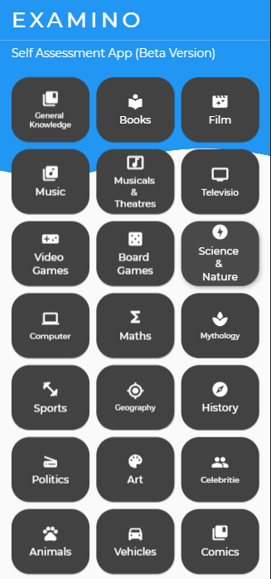

Figure 7. iPhone X (Preview)

# Tools and Technology

* Programming Language: Flutter Web
* Visual Studio Code
* Chrome Browser
* Kotlin Support for Android Platform
* Swift Support for iOS Platform

# Execution Timeline

The following table details our projected execution timeline for project.

|  |  |
| --- | --- |
| Stage | Completion Date |
| Project Kickoff Meeting | April 15, 2020 |
| Initial Design Wireframe | April 20, 2020 |
| Page Mockups | April 25, 2020 |
| Site Copy & Images | May 01, 2020 |
| Functional Prototype | May 18, 2020 |
| Website Development Complete | May 25, 2020 |
| Testing | June 01, 2020 |
| Website Launch | June 04, 2020 |

# Conclusion

In this way this website will be used for Self-Assessment by COMSIAN at COMSATS University Islamabad. This website is developed with Flutter. That’s why there will be generated Android and iOS App that will perform the same function with enhanced platform support.